Budget Management Portal
Software Requirements Specification (SRS)

1. Organization Structure
The Budget Management Portal is designed for South Eastern Region Pipelines (SERPL) of Indian Oil Corporation Limited. The portal shall support budget preparation, approval, and monitoring for all operating pipelines under SERPL.
SERPL consists of two Company Codes, each managing specific pipelines.

Company Code | Pipeline
9320 | PHPL
9320 | PRRPL
9280 | PHBPL
9280 | PSHPL

2. Organizational Hierarchy
The organizational hierarchy for budget preparation shall be as follows:

SERPL
│
├── Company Code 9320
│ ├── PHPL
│ └── PRRPL
│
└── Company Code 9280
├── PHBPL
└── PSHPL
Each pipeline operates through multiple Base Offices, and each Base Office controls multiple operating locations

3. . Base Offices

The following Base Offices shall be configured in the application.
- Paradip
- Bhubaneswar
- Sambalpur
- ERPL
- Vijayawada
Each location shall belong to only one Base Office.

4.. Location Mapping
Every operating location shall be mapped with the following attributes:
- Company Code
- Pipeline
- Base Office
- Cost Centre
- Location Name
Details given in excel sheet -name Location mapping .

5. roles ..
Level | Role | Responsibility | Scope
Level 1 | Location User | Prepare and submit the budget | Own operating location only
Level 2 | Base In-charge | Review and approve/return budgets | All operating locations under the respective Base
Level 3 | Technical Services (TS) Department – Regional Office | Technical review and approval | All five Bases across SERPL
Level 4 | Finance Department – Regional Office | Final financial review and approval | All Company Codes, Pipelines, Bases and Locations

Level 1 – Location User
The Location User shall:
- Log in using the organization's Active Directory (Windows) credentials.
- Save the budget as Draft.
- Modify the budget until submission.
- Submit the budget to the respective Base In-charge.
- View the current approval status.
- View remarks provided by approvers if the budget is returned.

Level 2 – Base In-charge
The Base In-charge shall:
- View budgets submitted by all operating locations under the assigned Base.
- Review the submitted budgets.
- Approve the budget and forward it to the Regional TS Department.
- Return the budget to the respective Location User with comments for correction.
The Base In-charge shall not be permitted to access budgets belonging to other Bases.

Level 3 – Technical Services (TS) Department
The Regional TS Department shall:
- View all budgets approved by Base In-charges.
- Review technical requirements and justifications.
- Approve the budget and forward it to the Finance Department.
- Return the budget to the concerned Base In-charge with remarks for revision.
The TS Department shall have access to budgets from all five Bases.

Level 4 – Finance Department
The Finance Department shall:
- Review budgets approved by the TS Department.
- Verify financial provisions and budget allocations.
- Approve and finalize the budget.
- Return the budget to the TS Department with remarks if revisions are required.
Upon Finance approval, the budget shall be marked as Final Approved and shall become read-only unless a formal budget revision process is initiated.

6. Modules .
There are 5 modules we need to develop .

A) Home
B) Create
C) Approve
D) Reports.
E) Authorization

Will Discuss about home .

First this will access to all user who ever logins into this portal .
first will be SERPL overall will display for all .then filter will be in pipelines .then filter will be on base if any one wants see for partuculer base they will select the SERPL ovaeral an peiplines also all .then they will select the base .forther filter will be oearating location .if any one wants see the for thire paritucler location

2 tables will display in home tab
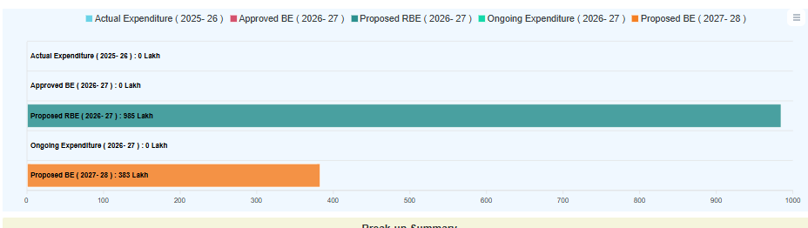

Actual expenditure 2025-26 -This will be maintained in system by finance dept
Approved BE 2026-27 - This will be maintained in system by finance dept
Proposed RBE 2026-27- this will be filled by the user from different locations
Ongoing Expenditure 2026-27- this will be maintained by finance dept from time to time
Proposed BE-2027-28 - this will be filled by the user from different locations.

Create tab .

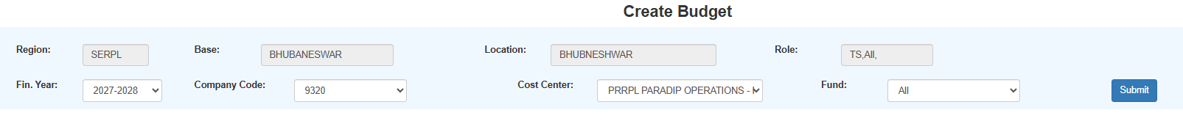

In create tab as per base mapping for employee will able to crete budget for mapped base locations only same thing will be there for new portal .
Once select the submit button after selecting budget .

